**Chapter 3**

**Introduction**

In this chapter, we have defined requirements gathering and the functional, and non-functional requirements, as well as a use case diagram with its specifications and an ER diagram.

**3.1. Requirements Gathering**

We looked at similar apps and extracted the most important requirements that they either have or lack.

**3.2. Functional Requirements (basic, middle, and high priority requirements)**

**FR1** the system must allow the user to take a picture of a plant. (high)

**FR2** the system must identify the plant. (high)

**FR3** the system must show the plant information. (high)

**FR4** the system shall allow the user to create an account with a username and password. (middle)

**FR5** the system shall allow the user to login by entering a username and a password(medium)

**FR6** the system shall save the plant to their account (medium)

**FR7** the system shall allow the user to set a reminder(low)

**FR8** the system shall allow the user to add a product for sale in the store. (medium)

**FR9** the system shall allow the user to buy a product (medium)

**3.3. Non-Functional Requirements**

**NF1** the system should allow the user to create a username and password for their account

**NF2** the system must display plant information in less than 5 minutes.

**NF3** the system must run on mobile devices

**NF4** the system must be easy to use

**NF5** the system must allow easy navigation within the application.

**NF6** The app must have bi-language support, displaying information in both English and Arabic**.**

**3.4. Use-case Diagram**

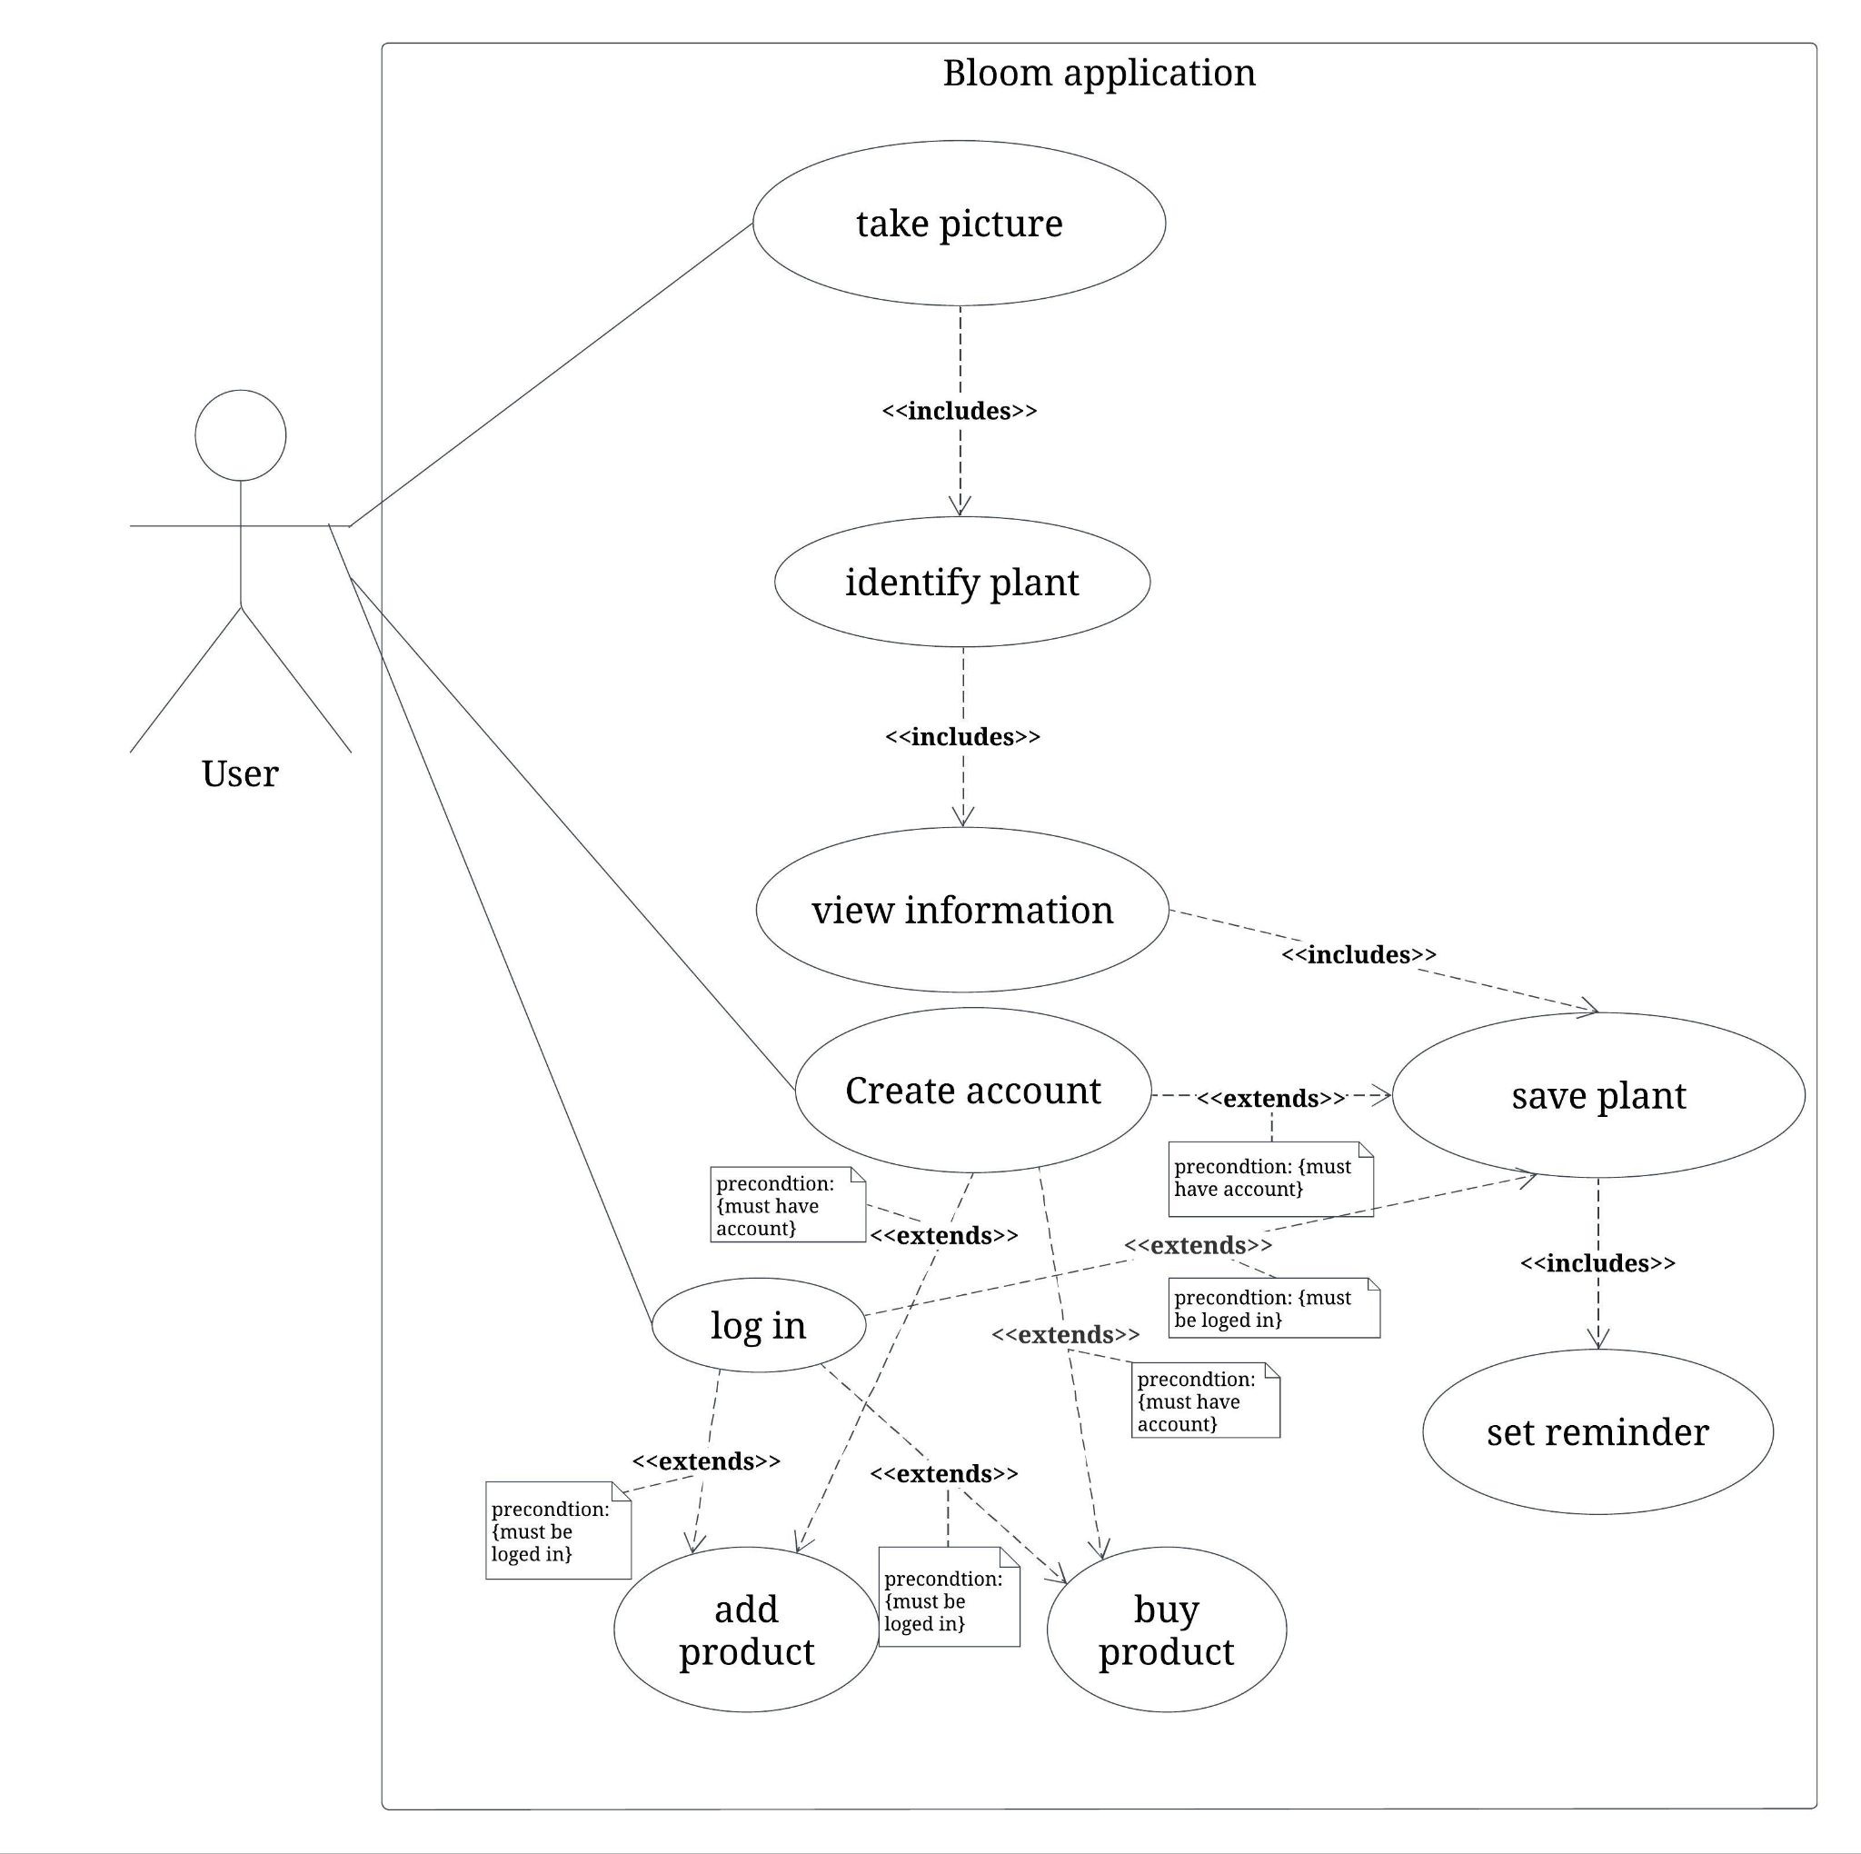

**3.5. Use-case Specifications**

|  |  |
| --- | --- |
| Use Case name | Take Picture |
| Use Case- Description | The system must allow the user to take pictures of plants for identification. |
| Actors | User |
| Precondition | The user must have the application installed. |
| Post Condition | The user successfully captures a picture of a plant. |

|  |  |
| --- | --- |
| Use Case name | Identify plant |
| Use Case- Description | The system must allow the user to identify plants by capturing and submitting photos. |
| Actors | User |
| Precondition | The user must take or submit a photo of a plant to be identified. |
| Post Condition | The system successfully identifies the plant from the submitted photo. |

|  |  |
| --- | --- |
| Use Case name | View information |
| Use Case- Description | The system must allow the user to view detailed information about a plant. |
| Actors | User |
| Precondition | The system should have identified a plant from the user’s photo. |
| Post Condition | The user successfully views detailed information about the selected plant. |

|  |  |
| --- | --- |
| Use Case name | Create account |
| Use Case- Description | The system must allow the user to create a new account to access application features. |
| Actors | User |
| Precondition | The user must have the application installed and have attempted to save the information of a plant identified, or tried to access the E-store. |
| Post Condition | The user successfully creates a new account. |

|  |  |
| --- | --- |
| Use Case name | login |
| Use Case- Description | A user provides a username and password to gain access to the system |
| Actors | User |
| Precondition | The user must have a registered account with the system |
| Post Condition | Upon successful authentication, the user gains access to the system |

|  |  |
| --- | --- |
| Use Case name | Save plant |
| Use Case- Description | The system must allow the user to save plant information for future reference. This functionality extends from the “View Plant Information” use case. |
| Actors | User |
| Precondition | The user must have the app installed, be logged in, and have viewed plant information. |
| Post Condition | The user successfully saves the plant information for future reference. |

|  |  |
| --- | --- |
| Use Case name | Set Reminder |
| Use Case- Description | The system must allow the user to set a reminder for plant care tasks. |
| Actors | User |
| Precondition | The user must have an account and be logged in, and saved plant information. |
| Post Condition | The user successfully sets a reminder for watering of the saved plant. |

|  |  |
| --- | --- |
| Use Case name | Sell product |
| Use Case- Description | The system must allow the user to add a product to the E-store to sell. |
| Actors | User |
| Precondition | The user must have viewed the store and be logged in. |
| Post Condition | The user successfully adds a product to sell |

|  |  |
| --- | --- |
| Use Case name | Buy product |
| Use Case- Description | The system must allow the user to pay for a product from the store after viewing its offerings. |
| Actors | User |
| Precondition | The user must have logged in, viewed the store, and added a product to their cart. |
| Post Condition | The user successfully completes the payment for the selected product. |

**3.6. ER Diagram**

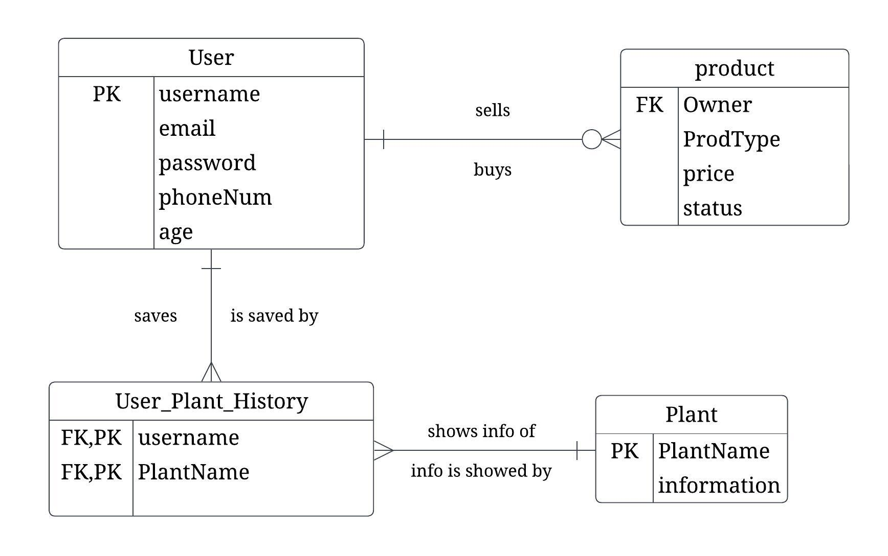

**3.7.Constraints**

Technical Constraints:

* Development and maintenance of an extensive plant database with accurate information and images.
* Continuous improvement of image recognition algorithms to enhance accuracy and speed of plant identification.
* Ensuring compatibility with a wide range of mobile devices and operating systems.

Time and Schedule Constraints:

* Balancing development timelines with user demands for new features and improvements.
* Adhering to release schedules for platform updates and bug fixes.
* The project's financial resources may limit acquiring necessary tools and technologies, potentially affecting the development timeline.

Ethical Constraints:

* Ensuring user privacy and data security, especially regarding the collection and use of personal information.
* Providing transparent information about how user data is used and shared.
* Addressing potential biases in image recognition algorithms and ensuring fair treatment of all users.

**3.8. Conclusion**

This chapter covered the functional, the non-functional requirements, the use case diagram with its specifications, the ER diagram, and the constraints of our application development.